# Instruction

Name Surname: Yusuf Güngör

Student ID: 20170703099

Group with: Alone

# Job

We took an assignment and, in this assignment, being wanted to build a database to manage zoos.

In this assignment, customers go to buy ticket and with this ticket they can enter zoos. Every costumer has a unique id, and every customers name, surname, email, address, credit card no must be stored.

Every ticket has a valid date, price and every ticket bought by customer has a ticket number. One customer can buy more than one ticket and tickets are manages by employees.

Employees are assigned zoos and every zoo has at least one employee. Each employee’s name, surname, phone number, and salary must be stored and also every employee has ana unique id number that assigned itself. Also, employees look after animal and al least one animal must assign an employee.

Zoos has phone numbers, unique id, location, name. Each zoo has an animal guide and animal guides keep some information about zoo. In guides zoo intro data and updated year info must be stored. Each guide has a unique id.

Each animal guide keeps information about animal kind and animal kind find at least one animal guide. Every animal kind keeps the data that zoo region, kind name, diet and population status. Also, each one has a unique id.

Animals consist of animal kind so each animal consist of animal kind. Each animal has a unique id, cage number, gender, feed time. Each animal has an animal detail. In this animal detail we are desired to store height, weight, age that animal. In addition, each animal detail has an id number.

# E-R Diagram

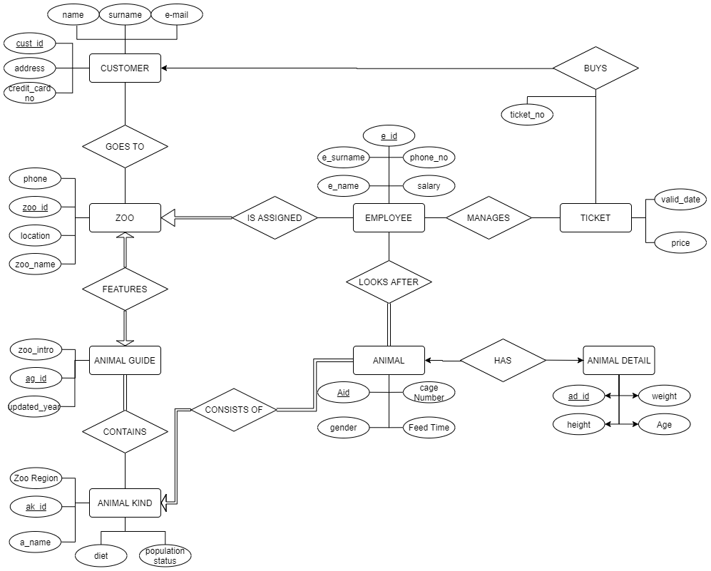

# CREATING TABLES SQL QUERY

CREATE TABLE CUSTOMERS(

CUST_ID INT PRIMARY KEY,

ADDRESS VARCHAR(15),

NAME VARCHAR(15) NOT NULL,

SURNAME VARCHAR(15) NOT NULL,

EMAIL VARCHAR(15) NOT NULL,

C_CARDNO VARCHAR(15)

)

CREATE TABLE TICKETS(

TICKET_NO INT PRIMARY KEY,

VALID_DATE SMALLDATETIME NOT NULL,

PRICE MONEY,

CUST_NUM INT

)

CREATE TABLE ZOO(

ZOO_ID INT PRIMARY KEY,

LOCATION VARCHAR(50),

ZOO_NAME VARCHAR(15) NOT NULL,

PHONE VARCHAR(15) UNIQUE

)

CREATE TABLE ANIMALGUIDE(

AG_ID INT PRIMARY KEY,

ZOO_INTRO VARCHAR(100),

UPDATEDYEAR SMALLDATETIME,

ZOO_ID INT UNIQUE

)

CREATE TABLE ANIMALKIND(

AK_ID INT PRIMARY KEY,

ZOO_REGION VARCHAR(15),

KIND_NAME VARCHAR(15),

DIET VARCHAR(15),

POPULATION_STATUS VARCHAR(10),

)

CREATE TABLE ANIMAL(

A_KIND_ID INT,

ANIMAL_ID INT PRIMARY KEY,

CAGE_NUMBER INT,

GENDER CHAR(1),

FEEDTIME DATETIME,

)

CREATE TABLE ANIMAL_DETAIL(

AD_ID INT PRIMARY KEY,

A_ID INT,

HEIGHT FLOAT,

WEIGHT FLOAT,

AGE TINYINT,

)

CREATE TABLE EMPLOYEE(

E_ID INT PRIMARY KEY,

NAME VARCHAR(15),

SURNAME VARCHAR(15),

PHONE_NUM VARCHAR(15),

SALARY MONEY,

ZOO_ID INT

)

CREATE TABLE LOOKSAFTER(

EMP_ID INT NOT NULL,

ANIMAL_ID INT NOT NULL

)

CREATE TABLE GOESTO(

C_ID INT NOT NULL,

Z_ID INT NOT NULL

)

# INSERTING DATA

INSERT INTO CUSTOMERS VALUES (

1,

'ISTANBUL',

'CENGIZ',

'HATIP',

'ch@gmail.com',

123)

INSERT INTO CUSTOMERS VALUES (

2,

'ANKARA',

'BURAK',

'KARA',

'brk@gmail.com',

1234)

INSERT INTO CUSTOMERS VALUES (

3,

'EDIRNE',

'YASIN',

'TRKYLMZ',

'97htt@gmail.com',

1235)

INSERT INTO TICKETS VALUES(

1,

'08-16-2020',

5,

2

)

INSERT INTO TICKETS VALUES(

2,

'08-16-2021',

5,

1

)

INSERT INTO TICKETS VALUES(

3,

'01-16-2020',

5,

3

)

INSERT INTO TICKETS VALUES(

4,

'08-16-2022',

5,

NULL

)

INSERT INTO ZOO VALUES(

1,

'ISTANBUL',

'DARICA',

'2122800066'

)

INSERT INTO ZOO VALUES(

2,

'ISTANBUL',

'EYUP',

'2123250066'

)

INSERT INTO ZOO VALUES(

3,

'ISTANBUL',

'KAGITHANE',

'2124272792'

)

INSERT INTO GOESTO VALUES(1,3)

INSERT INTO GOESTO VALUES(2,1)

INSERT INTO GOESTO VALUES(3,2)

INSERT INTO ANIMALGUIDE VALUES(

1,

'DARICA ZOO IS A...',

'08-16-2005',

1)

INSERT INTO ANIMALGUIDE VALUES(

2,

'Kağıthane ZOO IS A...',

'10-01-2006',

2)

INSERT INTO ANIMALGUIDE VALUES(

3,

'Eyüp ZOO IS A...',

'11-10-2012',

3)

/* ANIMLA KIND */

INSERT INTO ANIMALKIND VALUES(

1,

'SAFARI',

'CHEETAH',

'MEAT',

'WIDE')

INSERT INTO ANIMALKIND VALUES(

2,

'FOREST',

'PANDA',

'VEGETABLES',

'RARE')

INSERT INTO ANIMALKIND VALUES(

3,

'EGYPT',

'CAMEL',

'VEGETABLES',

'WIDE')

/*ANIMAL*/

INSERT INTO ANIMAL VALUES(

1,1,100,'M','01-01-2000 16:00')

INSERT INTO ANIMAL VALUES(

2,2,101,'F','01-01-2000 17:00')

INSERT INTO ANIMAL VALUES(

3,3,103,'M','01-01-2000 16:00')

/* ANIMAL DETAIL */

INSERT INTO ANIMAL_DETAIL VALUES(

1,1,1.5,50,5)

INSERT INTO ANIMAL_DETAIL VALUES(

2,2,1,30,4)

INSERT INTO ANIMAL_DETAIL VALUES(

3,3,2.1,70,8)

/*EMPLOYEE*/

INSERT INTO EMPLOYEE VALUES(

1,'YUSUF','GUNGOR','21221221',1500,1)

INSERT INTO EMPLOYEE VALUES(

2,'ESRA','LARA','21225621',2500,2)

INSERT INTO EMPLOYEE VALUES(

3,'YASIN','UMUT','21267221',1000,3)

/*looks after*/

INSERT INTO LOOKSAFTER VALUES(1,2)

INSERT INTO LOOKSAFTER VALUES(2,1)

INSERT INTO LOOKSAFTER VALUES(3,3)

# QUERIES

* A query that applies a row and column selection to a single table

/* SHOW ANIMAL IDS OF THE ANIMAL WHO ARE MALE*/

SELECT ANIMAL_ID

FROM ANIMAL

WHERE GENDER = 'M'

* A query that takes join of two tables and does row and column selection and ordering.

/* SHOW CAGENUMBER AND HEIGHT OF ANIMALS THAT AGES ARE GREATER THAN 5 AND ORDER THEM WITH ASCENDING ORDER BY HEIGHT*/

SELECT CAGE_NUMBER, HEIGHT

FROM ANIMAL JOIN ANIMAL_DETAIL ON ANIMAL_ID = A_ID

WHERE AGE>5

ORDER BY HEIGHT ASC

* Repeat the previous task but this time your query should take join of three tables

/*SHOW NAME OF THE EMPLOYEES WHO LOOK AFTER ANIMALS THAT OVER 5 AGE AND ORDER THEM WİTH ASCENDING ORDER*/

SELECT EMPLOYEE.NAME

FROM EMPLOYEE JOIN LOOKSAFTER ON EMP_ID=E_ID JOIN ANIMAL_DETAIL ON ANIMAL_ID=A_ID

WHERE AGE>5

ORDER BY NAME ASC

* Write a query involving outer join and row selection.

/* show the name and surname of the employees which is works on Istanbul zoo and how are salary is greater than 1000*/

SELECT EMPLOYEE.NAME,EMPLOYEE,SURNAME

FROM EMPLOYEE FULL OUTER JOIN ZOO ON EMPLOYEE.ZOO_ID = ZOO.ZOO_ID

WHERE LOCATION = 'Istanbul' and SALARY>1000

* Write two queries involving summary functions and row selection and join operations.

/*mean of animals age which are male */

SELECT AVG(age)

FROM ANIMAL JOIN ANIMAL_DETAIL ON A_ID=ANIMAL_ID

WHERE gender='M'

/*COUNT THE NUMBER OF EMPLOYEE WHO LOOKS AFTER THE ANIMALS WHİCH ARE IN THE CAGE NUMBER 101*/

SELECT COUNT(DISTINCT EMP_ID)

FROM ANIMAL JOIN LOOKSAFTER ON ANIMAL.ANIMAL_ID = LOOKSAFTER.ANIMAL_ID

WHERE CAGE_NUMBER = 101

* Write two queries involving join, grouping, row selection and ordering

/* SHOW ANIMAL KINDS AND THE NUMBERS OF ANIMAL THAT'S TYPE WİTH ASCENDİNG ORDER ACCORDING TO NUMBER OF THAT TYPE ANIMAL */

SELECT KIND_NAME,COUNT(ANIMAL_ID) AS COUNT

FROM ANIMALKIND JOIN ANIMAL ON AK_ID=A_KIND_ID

GROUP BY KIND_NAME

ORDER BY COUNT(ANIMAL_ID) ASC

/* SHOW NAME OF CUSTOMERS AND THE AVG PAID MONEY FOR TICKET THAT CUSTOMER AND ORDER THEM WITH DESCENDING ORDER WITH RESPECT TO PAID MONEY

*/

SELECT NAME,AVG(PRICE) AS AVG_PAID_MONEY

FROM CUSTOMERS JOIN TICKETS ON CUST_NUM=CUST_ID

GROUP BY CUSTOMERS.NAME

ORDER BY AVG(PRICE) DESC

* Write two queries involving join, grouping and group selection

/* SHOW ANIMAL KINDS AND THE NUMBERS OF ANIMAL THAT'S TYPE WİTH ASCENDİNG ORDER ACCORDING TO NUMBER OF THAT TYPE ANIMAL WHICH ARE NUMBER IS GREATER THAN 50*/

SELECT KIND_NAME,COUNT(ANIMAL_ID) AS COUNT

FROM ANIMALKIND JOIN ANIMAL ON AK_ID=A_KIND_ID

GROUP BY KIND_NAME

HAVING COUNT(ANIMAL_ID)>50

ORDER BY COUNT(ANIMAL_ID) ASC

/* SHOW NAME OF CUSTOMERS WHO BOUGHT MORE THAN TWO TICKET AND THE AVG PAID MONEY FOR TICKET THAT CUSTOMER AND ORDER THEM WITH DESCENDING ORDER WITH RESPECT TO PAID MONEY

*/

SELECT NAME,AVG(PRICE) AS AVG_PAID_MONEY

FROM CUSTOMERS JOIN TICKETS ON CUST_NUM=CUST_ID

GROUP BY CUSTOMERS.NAME

HAVING COUNT(TICKET_NO)>2

ORDER BY AVG(PRICE) DESC

* Write a query involving join, grouping, group selection and row selection

/* SHOW ANIMAL KINDS WHICH ARE FEMALE AND THE NUMBERS OF ANIMAL THAT'S TYPE WİTH ASCENDİNG ORDER ACCORDING TO NUMBER OF THAT TYPE ANIMAL WHICH ARE NUMBER IS GREATER THAN 50*/

SELECT KIND_NAME,COUNT(ANIMAL_ID) AS COUNT

FROM ANIMALKIND JOIN ANIMAL ON AK_ID=A_KIND_ID

WHERE GENDER='F'

GROUP BY KIND_NAME

HAVING COUNT(ANIMAL_ID)>50

ORDER BY COUNT(ANIMAL_ID) ASC

/* SHOW NAME OF CUSTOMERS WHO BOUGHT MORE THAN TWO TICKET WHICH IS GREATER THAN 50 DOLAR AND THE AVG PAID MONEY FOR TICKET THAT CUSTOMER AND ORDER THEM WITH DESCENDING ORDER WITH RESPECT TO PAID MONEY

*/

SELECT NAME,AVG(PRICE) AS AVG_PAID_MONEY

FROM CUSTOMERS JOIN TICKETS ON CUST_NUM=CUST_ID

WHERE PRICE>50

GROUP BY CUSTOMERS.NAME

HAVING COUNT(TICKET_NO)>2

ORDER BY AVG(PRICE) DESC